# NAAN MUDHALVAN PROJECT REPORT

On

## “A REVIEW OF LIVER PATIENT ANALYSIS METHODS USING MACHINE LEARNING”

## Submitted in partial fulfillment of the requirements for the award of the degree of

***BACHELOR OF SCIENCE***

***ON***

***COMPUTER SCIENCE***

***Submitted By***

***Team Leader***

***Esakkiammal. C (Reg. No: 20201371506106)***

***Team Members***

***Anusiya. B (Reg. No : 20201371506101)***

***Jothi. P (Reg. No: 20201371506110***

***Muthulakshmi. M (Reg. No: 20201371506120)***



***Department of Computer Science***

***Government Arts and Science College For Women ,Alangulam***

***Tenkasi - 627851***

***April-2023***

### A Review of Liver Patient Analysis Methods Using Machine Learning

### 

### 1. INTRODUCTION

#### Liver patient analysis refers to the process of evaluating the liver health of an individual through various tests and examinations. The liver is one of the most important organs in the body, responsible for various functions such as detoxification, metabolism of nutrients, and production of bile. When the liver is not functioning properly, it can lead to serious health issues. Liver patient analysis includes a range of tests such as liver function tests (LFTs), imaging studies, and biopsy. LFTs are blood tests that measure the levels of enzymes and proteins produced by the liver. Imaging studies, such as ultrasound or CT scans, can help to identify abnormalities in the liver such as tumors, cysts, or fatty liver disease. Biopsy involves taking a small sample of liver tissue to be examined under a microscope to determine the cause and extent of liver damage. The analysis of liver function is important for the diagnosis, management, and treatment of liver diseases such as hepatitis, cirrhosis, and liver cancer. The results of these tests can help doctors to determine the severity of liver damage, identify the underlying cause of liver disease, and develop an appropriate treatment plan for the patient. Early detection and intervention can help to prevent further liver damage and improve the overall health and well-being of the patient.

### Overview

#### The evaluation of liver health includes a range of tests, such as liver function tests (LFTs), imaging studies, and biopsy. LFTs are blood tests that measure the levels of enzymes and proteins produced by the liver. Imaging studies such as ultrasound, CT scans, and MRI can help identify abnormalities in the liver, such as tumors, cysts, or fatty liver disease. Biopsy involves taking a small sample of liver tissue to be examined under a microscope to determine the cause and extent of liver damage. Liver patient analysis is critical for the diagnosis , management, and treatment of liver diseases.

#### The results of these tests help doctors determine the severity of liver damage, identify the underlying cause of liver disease, and develop an appropriate treatment plan for the patient. Treatment options for liver diseases may include lifestyle modifications, medications, and surgical interventions such as liver transplant. Early detection and intervention can help prevent further liver damage and improve the overall health and well-being of the patient. In summary, liver patient analysis is a vital component of liver disease management, and accurate diagnosis and assessment are crucial for optimal patient outcomes. This project compares various classification algorithms such as Random Forest, Logistic Regression, KNN and ANN Algorithm with an aim to identify the best technique.

# Purpose

#### The purpose of liver patient analysis is to evaluate and assess the health and function of the liver. The liver is a vital organ responsible for several essential functions in the body, including detoxification, metabolism of nutrients, and production of bile. When the liver is not functioning correctly, it can lead to severe health problems, including liver diseases such as hepatitis, cirrhosis, and liver cancer. Liver patient analysis involves a range of tests, such as liver function tests (LFTs), imaging studies, and biopsy, to diagnose liver diseases and determine the extent and severity of liver damage. The results of these tests help doctors develop an appropriate treatment plan for the patient, which may include lifestyle modifications, medications, and surgical interventions such as liver transplant. Early detection and intervention through liver patient analysis can help prevent further liver damage and improve the overall health and well-being of the patient. The purpose of liver patient analysis, therefore, is to ensure accurate diagnosis, appropriate treatment, and optimal patient outcomes for liver diseases

### 2. PROBLEM DEFINITION & DESIGN THINKING

# Empathy Map

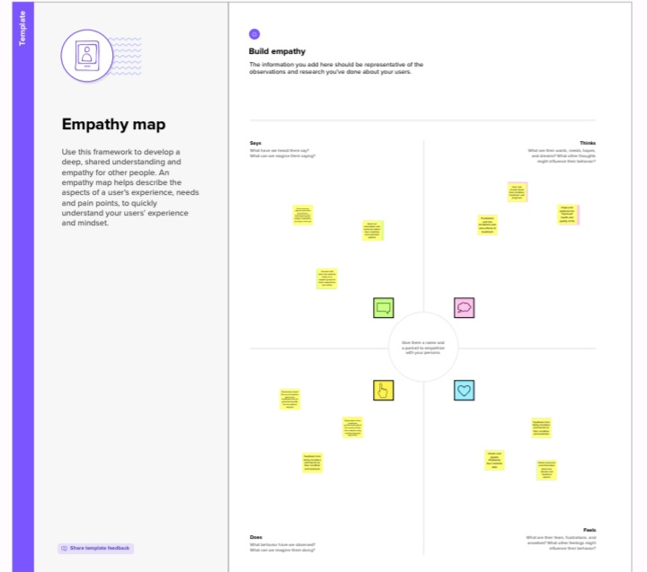

# Ideation & Brainstorming Map

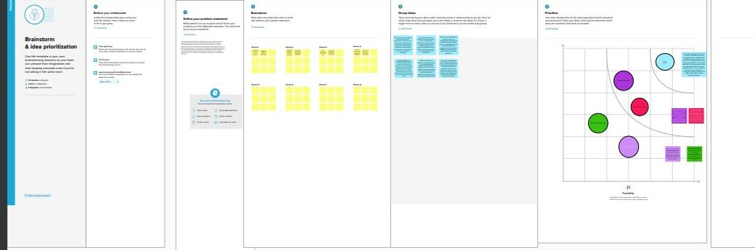

### 3. RESULT

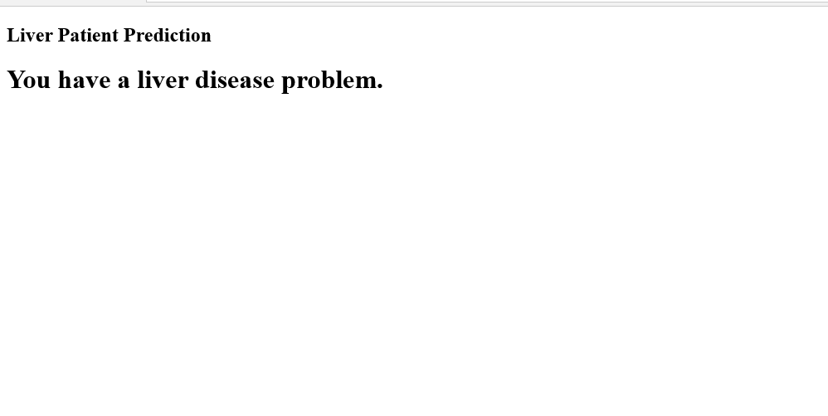

### 4. ADVANTAGES

* Early Detection: Liver patient analysis can help in the early detection of liver diseases. This can enable doctors to provide prompt and effective treatment, which can improve patient outcomes and quality of life.
* Accurate Diagnosis: Liver patient analysis can help in accurately diagnosing the type and severity of liver disease, which can guide treatment decisions and improve patient outcomes.
* Personalized Treatment: Liver patient analysis can help in developing personalized treatment plans based on the specific needs of each patient. This can improve treatment efficacy and reduce side effects.

#### Monitoring Disease Progression: Liver patient analysis can be used to monitor disease progression and treatment effectiveness over time. This can help doctors adjust treatment plans as needed and ensure that patients are receiving the best possible care.

### 5. DISADVANTAGES

* Invasive Testing: Some tests used for liver patient analysis, such as liver biopsies, can be invasive and carry a risk of complications.
* Limited Availability: Advanced liver patient analysis methods, such as imaging studies or genetic testing, may not be available in all healthcare settings.
* Cost: Some liver patient analysis methods can be expensive, which may limit their use in certain populations or healthcare systems.
* False Positives and Negatives: Liver patient analysis can produce false positive or false negative results, leading to incorrect diagnoses or treatment decisions.
* Limited Predictive Value: Some liver patient analysis methods may not accurately predict disease progression or treatment response, making it difficult for doctors to develop effective treatment plans.

#### 

### 6. APPLICATIONS

* Treatment Planning: Liver patient analysis can help in developing personalized treatment plans based on the specific needs of each patient. This can improve treatment efficacy and reduce side effects.
* Disease Monitoring: Liver patient analysis can be used to monitor disease progression and treatment effectiveness over time. This can help doctors adjust treatment plans as needed and ensure that patients are receiving the best possible care.
* Prognosis: Liver patient analysis can help doctors predict disease progression, treatment response, and patient outcomes, enabling them to make more informed treatment decisions.
* Research: Liver patient analysis can be used in research to identify new diagnostic markers, develop new treatments, and improve our understanding of liver diseases.
* Population Health Management: Liver patient analysis can be used to identify high-risk populations for liver diseases, enabling doctors to provide targeted prevention and screening efforts.

#### 7. CONCLUSION

#### In conclusion, liver patient analysis is a crucial component of diagnosing and managing liver diseases. Traditional analysis methods, such as blood tests and imaging studies, have been used for many years to diagnose liver diseases, but machine learning methods offer several advantages, including improved accuracy, personalized treatment plans, faster diagnosis, early detection, predictive modeling, and cost-effectiveness.

#### However, machine learning methods also have limitations, such as the need for high-quality data, limited interpretability, potential for bias, over fitting, limited availability, and legal and ethical concerns. Therefore, it is important to carefully consider the potential advantages and disadvantages of different liver patient analysis methods before implementing them in clinical practice.

#### Despite these challenges, liver patient analysis has numerous applications that can improve patient outcomes, reduce healthcare costs, and enhance our understanding of liver diseases. By continuing to develop and refine liver patient analysis methods, we can improve our ability to diagnose and manage liver diseases and improve the lives of patients affected by these conditions.

### 8. FUTURE SCOPE

#### The future scope of liver patient analysis is exciting and promising, with several new and emerging technologies and techniques that have the potential to revolutionize the field. Here are some of the potential future developments in liver patient analysis:

* Artificial Intelligence: The use of artificial intelligence and machine learning algorithms in liver patient analysis is likely to become more widespread, allowing for more accurate diagnosis, faster treatment, and personalized medicine.
* Genomic Analysis: Genetic testing is already being used to identify individuals at risk of developing liver disease, and as the cost of genomic analysis decreases, it is likely that this technique will become more widely used for diagnosis and treatment planning.
* Non-Invasive Imaging: Advances in non-invasive imaging techniques, such as magnetic resonance imaging (MRI) and ultrasound, may make it possible to diagnose liver diseases without the need for invasive testing such as biopsies.

#### Biomarkers: There is growing interest in the use of biomarkers to diagnose liver disease, monitor disease progression, and predict treatment outcomes. These biomarkers may include proteins, metabolites, and other molecules that are specific to liver diseases.

* Precision Medicine: Advances in personalized medicine may make it possible to tailor treatments to individual patients based on their unique genetic and molecular profiles, improving treatment efficacy and reducing side effects.
* Telemedicine: The use of telemedicine and remote monitoring may make it possible for patients to receive liver patient analysis and treatment without the need for in-person visits to healthcare facilities.

#### Overall, the future of liver patient analysis is bright, with many new and emerging technologies and techniques that have the potential to improve patient outcomes, reduce healthcare costs, and enhance our understanding of liver diseases.

### 8. APPENDIX

# Source Code

